Wireless LAN & Network Devices
Easy notes — explained in very simple words

Part 1: Wireless LAN (802.11)

1. What is a Wireless LAN?
Imagine your computer talking to the internet without any wire. No cable, no string — just invisible radio waves flying through the air. That is a Wireless LAN. It lets devices connect to a network using radio signals instead of cables.

2. What is an Access Point (AP)?
An Access Point is like a friendly helper box. It catches the wireless signal from your laptop or desktop, and it also has a wire going to the big network. So it joins two worlds together — the wireless world and the wired world. We can say the AP works like a bridge between wireless devices and the wired network.
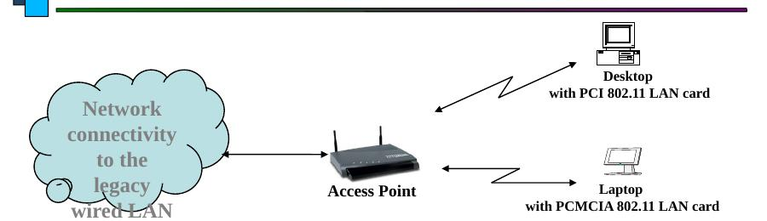
A Desktop and a Laptop both talk to the Access Point wirelessly. The Access Point is wired to the bigger network.
- A computer needs a special wireless card (called an 802.11 LAN card) to talk to the Access Point.
- The Access Point has small antennae (like little ears) to send and catch the radio signal.

3. How Far Can the Signal Reach? (Range)
The distance between an Access Point and a device is called the range. Walls, doors, and big objects can block the signal, so the range becomes shorter. To cover a big area like a whole building, many Access Points are placed with a little overlap (about 20-30%), like umbrellas overlapping so there is no gap with no signal.

4. Hand-Off — Moving Between Access Points
A device always talks to one Access Point at a time. When you walk closer to a different Access Point, your device quietly switches to the new, stronger one. This smooth switch is called Hand-Off. It is just like changing hands while carrying a baby — the baby never falls, it is passed gently from one arm to another.

5. Three Flavors of Wireless LAN
Wireless LAN comes in three common types, called 802.11a, 802.11b and 802.11g. Think of them as three different flavors of the same ice cream — same idea, but each one a little different in speed and the road (frequency band) they travel on.

5.1 802.11b
- The most common and most used type.
- Speed: 1, 2, 5.5 or 11 Mbps (megabits per second).
- Travels on the 2.4 GHz road, called the ISM band (Industrial-Scientific-Medical).

5.2 802.11a
- Travels on a different road: the 5 GHz band, called UNII.
- It cannot talk to 2.4 GHz devices — different road, no meeting.
- Faster: up to 54 Mbps.

5.3 802.11g
- Also fast: up to 54 Mbps.
- But it travels on the 2.4 GHz road, same as 802.11b.
- Because it shares the same road, it can also talk nicely with older 802.11b devices (backward compatible).

6. Multiple Access with Collision Avoidance (MACA)
When many devices want to talk over the air at the same time, their words can crash into each other — like two people shouting at once. MACA is a polite conversation rule that stops this crashing (collision).
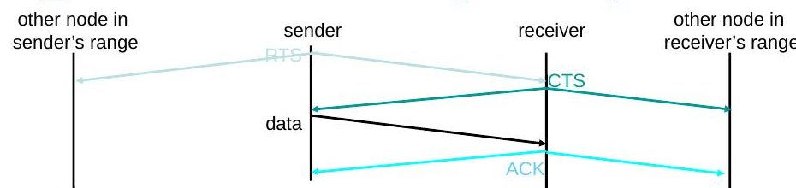
Sender and receiver politely take turns using RTS, CTS, data and ACK signals.
Here is the simple, step-by-step polite conversation, before any data is sent:
- Step 1: The sender first sends a small note called RTS (Request to Send). It says 'Hey, can I talk, and for how long?'
- Step 2: The receiver replies with CTS (Clear to Send). It says 'Yes, go ahead, I am listening.'
- Step 3: Now the sender sends the real data.
- Step 4: The receiver sends back an ACK (Acknowledgement), meaning 'I got it!' Now someone else may talk.
- If the sender does not get a CTS reply back, it thinks: 'Oops, maybe my note crashed with someone else.' This is called a collision.

Part 2: Repeater, Hub, Bridge and Switch
These four devices help carry data along a network. Think of them like helpers passing a parcel from one house to another. Each helper has a different, smarter way of passing it along.

1. Repeater
A repeater is like a person with a megaphone. The signal gets weak and quiet after traveling far, so the repeater listens to it, makes it strong again, and shouts it onward. It does not understand the message; it just makes it loud and clear again so it can travel further.
- It works at the lowest, simplest level (the Physical Layer).
- Rule of Four: For 10 Mbps Ethernet, no more than four repeaters should be used in a row between two computers.
- Why this rule? Each repeater adds a tiny delay. Too many repeaters in a row makes the message take too long to arrive.

2. Hub
A hub is like a megaphone with many speakers attached. It joins many computers together, and it is really just a repeater with multiple ports. The trick is: when a hub gets a message from one computer, it shouts that same message out to every other computer connected to it — except the one that sent it.
- It changes the shape of the network from a straight line (bus) into a star shape, with the hub in the middle.
- Everyone hears everything — it is not very private or efficient.

3. Bridge
A bridge is smarter than a hub. It does not just shout everything to everyone. It looks at the address label on each message (called a MAC address) and decides: should I let this message pass to the other side, or should I keep it here? This way, it keeps two parts of a network separate but connected when needed.
- It works one level smarter than a repeater (the Data Link Layer).
- It checks a table of addresses to decide: block it, copy it onward, or send it everywhere (flood).
- Messages meant for everyone (broadcast messages) are always passed along.

4. Switch
A switch is like a bridge with many doors (ports), one door for each computer. It is basically a multi-port bridge. Each computer gets its very own private road to the switch, so messages do not crash into each other.
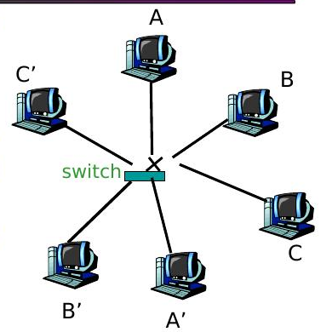
Each computer connects to the switch directly. A talks to A', B talks to B', and C talks to C' — all at the same time, with no crashing.
- Each computer has its own direct wire to the switch (dedicated access).
- Full Duplex means talking and listening can happen at the same time, with no collisions.
- Many pairs of computers (A-A', B-B', C-C') can talk at the very same moment without bumping into each other.
- Switches learn which computer is on which port, building a table, just like a bridge, but for many ports.
- You can connect switches together (cascade them) to make the network even bigger.

Quick Summary
- Wireless LAN lets devices connect using radio waves; the Access Point joins wireless and wired networks.
- 802.11b, 802.11a and 802.11g are three flavors with different speeds and radio roads.
- MACA uses RTS, CTS, data and ACK messages so wireless devices take turns and avoid crashing into each other.
- Repeater: makes a weak signal strong again.
- Hub: a repeater with many ports; shouts to everyone.
- Bridge: looks at addresses and smartly decides where a message should go.
- Switch: a smart bridge with many ports; gives each computer its own private, collision-free path.

